**Why Running Ads on Instagram Might Not Be Ideal for Content Creators**

For over a year now my Instagram account has been under the creator's account. I, myself, am a writer by passion and profession, and having said that, I often considered running ads to promote some of my favorite pieces or poems. Nevertheless, I was recently taught by [Viraj Mahajan](mailto:vmahajan2206@gmail.com)that running ads on Instagram is nothing but an inadequate practice for a content creator. 🔊

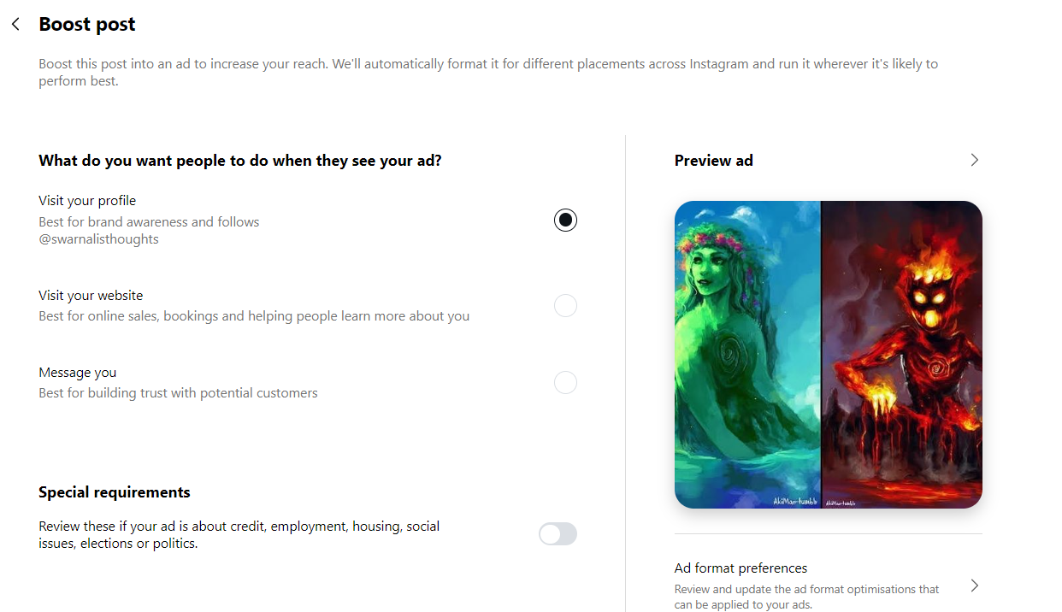

I have attached two screenshots in this post, which depict the alternatives @instagram gives us for boosting our posts. Some of the reasons are:c

* Limited Placements: One of the biggest disadvantages of running this ad is the limitation of placement. Most of us nowadays visit the #reel section more than stay on the home page. It makes genuine engagement or audiences more challenging to achieve.
* Limited Creatives: There is very limited creative content to post in this ad. While selling my content, I should have that command to show my audiences eclectic types of creatives based on their preferences on the app.
* Less Target Audience Option: Getting an option for a limited target audience also restricts your reachability to an authentic audience.
* Cost vs. Return: Running ads is undoubtedly an expensive practice, while the return on investment (ROI) is not worth the investment every single time. For beginner content creators, it is a financial burden. As we only get limited target options, for only one placement we are paying 84 rupees a day (which is also not guaranteed to return a good ROI).
* Ad Objective Choice: “Visit your profile,” “Visit your website,” and “Message you” are only their options for objectives. These are quite limited options, which might not align with the exact marketing goal.
* Algorithm Dependency: The algorithm of Instagram favors content that is paid. This feature leads to dependency on ads in accordance with visibility. This may also reduce the organic reach of the post.
* Ad Fatigue: Users often feel fatigued due to overexposure to ads. This has the potential for a negative impact on us while lower engagement reaches.

Instead, I focus on posting my content through Meta Events Manager. Yes, I do post on Instagram, but for ads and generating leads, @Meta Events Manager is the best. I’ll share more about this in my next post.

By the way, the attached image is one of my posts, where I wrote feedback on the beautiful movie #Moana 🌊🛶 produced by none other than @Osnat Shurerby via the company @Disney+ Hotstar. 🎥